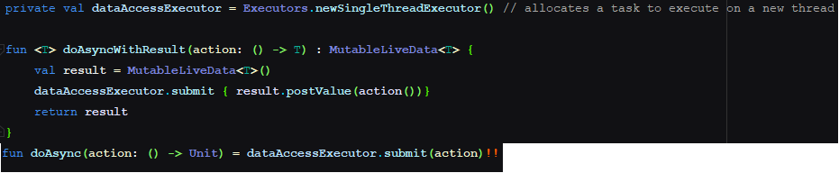

viewModel.isWhitesPlaying.observe(this{ currentColorPlaying.isChecked = it

}  
var isWhitesPlaying: MutableLiveData<Boolean> = MutableLiveData(true)

